Lakshmipur District, Bangladesh
(Established as a district: 28th Feb,1984)
N
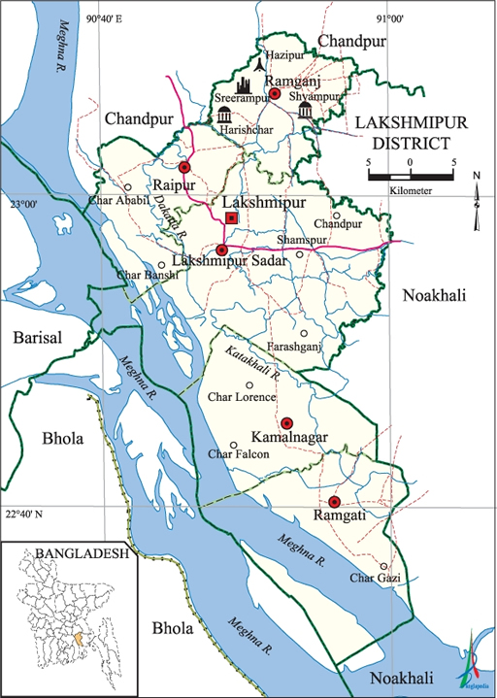

S
Fig: Map of Lakshmipur District

Visit Report: Civil Surgeon Office, Lakshmipur
Date of Visit: 14/09/22; Time: 8:30 AM
Visitor: Dr. Md. Emdadul Haque, National Consultant (HEU) &
Dr. Nazmur Rahman Sajib, Junior National Consultant (HEU)

1. We arrived at 8:30 am in the Civil Surgeon Office, Lakshmipur. We discussed with the Civil Surgeon about the overall activities of the health service system of the district. He is also in charge of Superintendent of the 100 bedded Lakshmipur Sadar Hospital.
2. We also discussed with him about the SSK program and role of the District Hospital and Upazila Health Complexes as well as the role of the health service providers in SSK.
3. The Civil Surgeon was very cordial and he ensured us to provide necessary support to implement SSK services.

Lakshmipur District Health Profile:
Total population: 19,38,111.
Upazilla: 5 Powroshova: 4 Union: 5

1. Sadar Hospital: 100 bedded.
2. Upazilla Health complex: 4 (Raipur UHC & Kamalnagar UHC are 50 Bedded, Ramganj & Ramgoti are 31 bedded).
3. Community Clinic: 179
4. Rural Dispensary: 21.
5. H & FWC: 30.

Status in HSS Score From Jan-July: (Total Dist. Hospital-64, Total UHC-423)
Name | Jan | Feb | Mar | April | May | June | July | Aug
Lakshmipur District Hospital | 2 | 1 | 2 | 2 | 3 | 3 | 55 | 55
Raipur UHC | 87 | 121 | 127 | 306 | 228 | 92 | 358 | 374
Ramganj UHC | 31 | 4 | 13 | 75 | 83 | 120 | 364 | 372
Kamalnagar UHC | 154 | 119 | 59 | 176 | 168 | 289 | 385 | 380
Ramgati UHC | 196 | 117 | 96 | 265 | 219 | 212 | 356 | 369

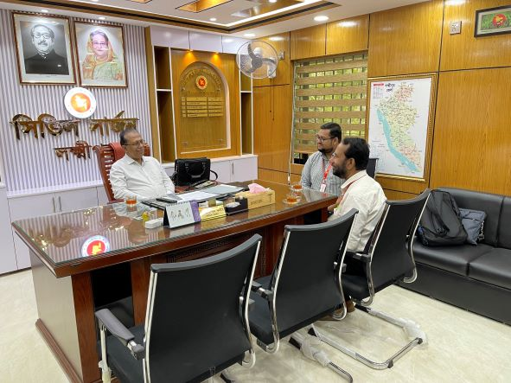
Fig: Meeting with Civil Surgeon cum Superintendent of Sadar Hospital, Lakshmipur

Visit Report: 100 Bedded Sadar Hospital, Lakshmipur.
Date of Visit: 14/09/22; Time: 9.00 AM.
Visitor: Dr. Md. Emdadul Haque, National Consultant (HEU) &
Dr. Nazmur Rahman Sajib, Junior National Consultant (HEU)

Objectives of the visit:
1. To perform the baseline health survey of the 100 bedded Sadar Hospital.
2. Discussion on the SSK program and importance of quality of health care.

Activities:
1.We arrived at 9.00 am in the hospital. Superintendent, consultants were present. We discussed with them about the overall situation of the hospital. We also discussed with them about the SSK program and role of the District Hospital in SSK.
2. Though the hospital is 100 bedded, but is running with 50 bedded human resource since 2003. There are 11 posts of consultants but 6 are vacant. One post of senior consultant gynae is there but vacant for a long period. The caesarian section is performing by medical officer having post-graduation degree.
3. There is no post of cashier, accountant and statistician. So, office management is difficult. There are three cleaners working in the hospital. There is no Aya, ward boy, and trolley-man.
4. The infra-structure of this hospital is 100 bedded. The physical condition of the hospital building is not satisfactory. There is another 150 bedded infra-structure building is under construction. There are occupied spaces in front of the under constructed building which hampers the external environment of the hospital.
5. We visited outdoor of the hospital which was crowded with patients. We also observed Emergency, pathology and pharmacy department. The information display system was not satisfactory. There was no effective health education system.
6. Cleanliness of the hospital premises and indoor was weak. There are separate operation theatres for performing major operations.
7. There is no cycle stand close to the main gate. There are many motorcycles parked within the premises.
8. The roof of the hospital was not clean.
9. There are spaces for SSK Booth and Pharmacy close to the emergency department.
10. In 2021, total OPD patient was 2,84,535. Indoor admitted patient was 29,277. Bed occupancy rate was 252%. Total ANC 1st visit in 2021 was 7350. Total delivery was 2176. Among them NVD was 1744, C-section was 432.

Human Resources of 100 Bedded Hospital: (running with 50 bedded human resource)
Sl. | Designation | No. of Post | Present | Vacant
 | Superintendent | 01 | 01 | 0
 | RMO | 01 | 01 | 0
 | Senior Consultant | 04 | 01 | 03
 | Junior Consultant | 07 | 05+03 (dupt.) | 02
 | Medical Officer + EMO | 06 | 05 | 01
 | MO(Dental) | 01 | 0 | 01
 | Medical Officer (OSD)  (Local order) | - | 13 | -
 | Nurses (Nursing Super+ SSN) | 2+87=89 | 2+67=69 | 20
 | Mid wives | 04 | 03 | 01
 | MT (Lab)  **One in higher education, 1 in deputed at Kurmitola Hospital  ** Running by Lab attendant | 02 | 02 | 0
 | MT(Dental) | 01 | 01 | 0
 | MT (Radiology) | 01 | 0 | 01
 | Pharmacist | 03 | 02 | 01
 | Head Assistant | 01 | 01 | 0
 | Cashier | 0 | 0 | 0
 | Accountant cum comp operator | 01 | 01 | 0
 | Statistician (No Post) | 0 | 0 | 0
 | Store Keeper | 01 | 01 | 0
 | Cardiographer | 0 | 0 | 0
 | MLSS+ Ward boy | 10 | 03 | 07
 | Cleaner | 04 | 03 | 01
 | Guard (outsourcing) | 02 | 02 | -
 | Gardener + Herbal Gardener | 01 | 01 | 0
 | Outsourcing: | 02 | 0 | 02
 | Driver | 03 | 03 | 0
 | Cook | 03 | 02 (one from outsourcing) | 01

Status of Building Blocks of C-J Model in the Lakshmipur Sadar Hospital:
Sl | Criteria of C-J Model | Satisfactory | Average | Weak
01 | Cycle stand close to the main gate |  |  | √
02 | Health Education |  |  | √
03 | Cleanliness & beautification |  |  | √
04 | Separation of patients in out door & indoor |  | √
05 | Blood donor list with 24/7 B.T facility |  | √
06 | Death Riview |  | √
07 | Reception Desk |  |  | √
08 | Developed Emergency Dept. |  | √
09 | 5S –KAIZEN implementation. |  |  | √
10 | Community Participation. |  |  | √
11 | Hospital activities Display |  |  | √
12 | Corner based service. |  | √
13 | Cash counter for receiving Govt money. |  |  | √
14 | Devolped maternal health/labour word. |  | √
15 | Devolped paediatric health | √
16 | Position in HSS score in July22.  (Best <10; Good 10-20; Weak >20) |  |  | √
17 | Power point Presentation &Video on UHC |  | √
18 | Knowledge about 8th Five Year plan & SDG. |  |  | √
19 | Zero-Tollarance on corruption |  | √

Recommendations:
1.The post creation of human resource of 100 bedded hospital is very essential to maintain the quality of health services.
2. Cleaning and beautification is not up to the mark. For waste management, involvement of Pouroshova is necessary. Pouroshova can take part in providing cleaners for the hospital like other district hospitals of the country.
3. Acquiring the areas in front of the under constructed hospital building is necessary. There is a pond behind the bulding which is also needs to be acquired.
4. All the vacant posts of consultants should be fullfilled. Senior consultant Gynae should be posted immediately. All the vacant posts of 3rd and 4th class should also be fulfilled.
6. Condemetion Board should work to destory all unwanted items.
7. There should be availability of safe drinking water.
8. Display system should be updated regularly and health education for the patients and their attendants should be introduced.
9. There should be 24/7 facility for caesarean section.
10. Toilet of the labor room should be repaired for the labor patients.

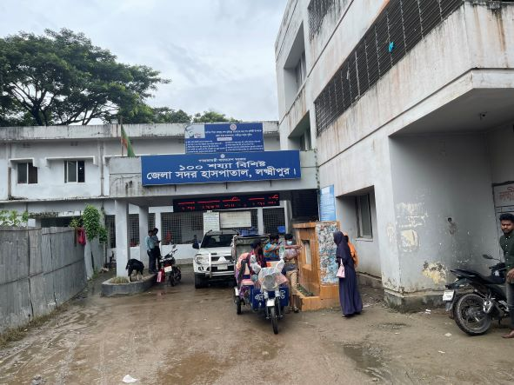
Fig-1: Entrance gate of Sadar Hospital

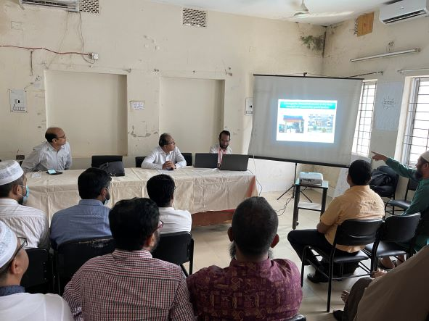

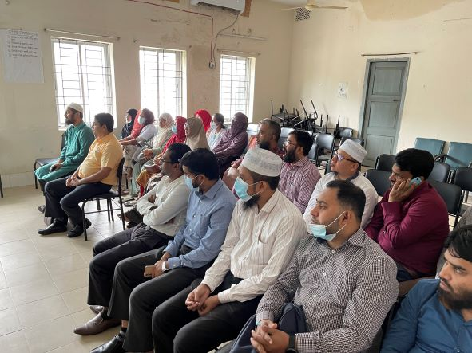

Fig-2,3: Discussion on SSK and Quality of Health Care with Doctors

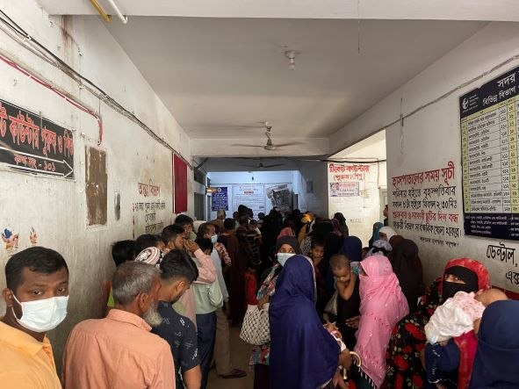

Fig-4: Overcrowded OPD

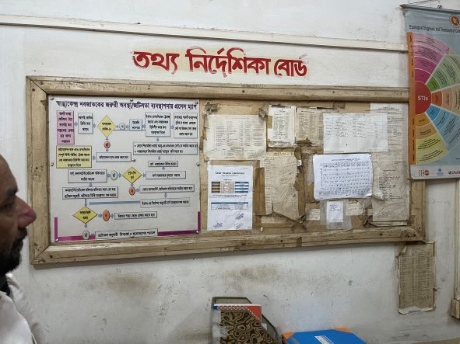

Fig-5: Display board not attractive and updated

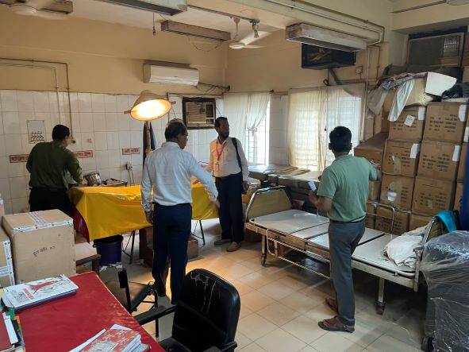
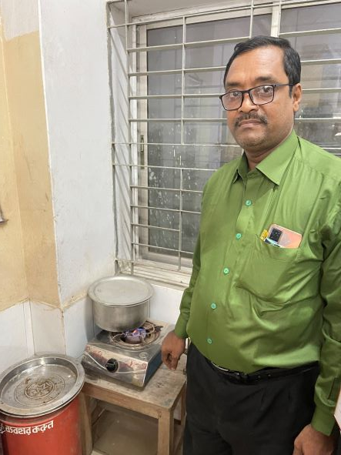
Fig-7: Disorganized emergency OT
Fig-6: Sterilization of the instruments of Emergency Dept. (Good Practice)

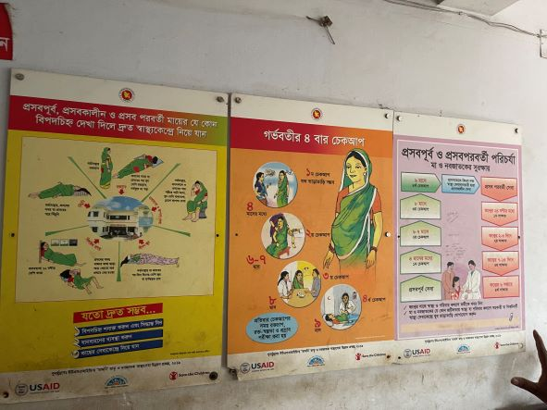

Fig-8: Information Display followed the KAIZEN rule
(Good Practice)

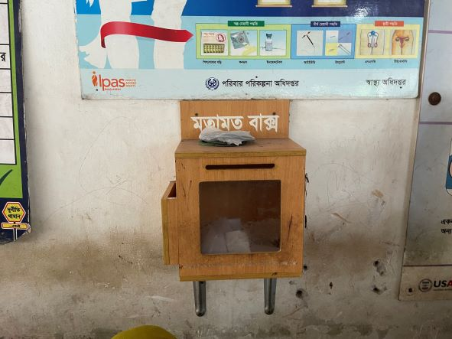

Fig-9: Suggestion Box
(Good Practice)

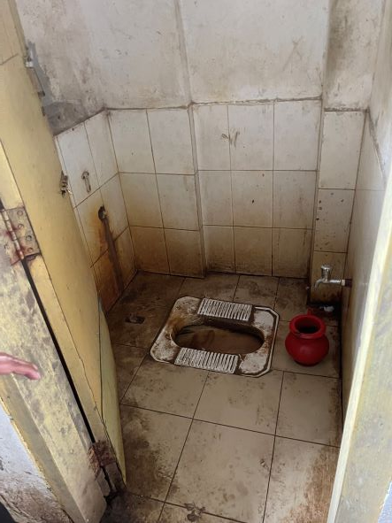
Fig-10: Unclean Toilet in outdoor

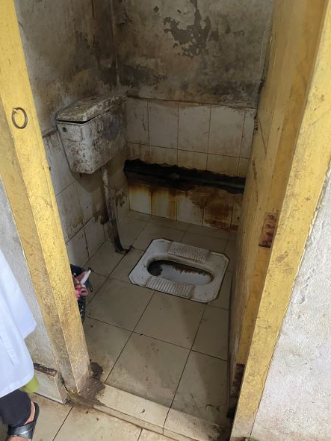

Fig-11: Unclean Toilet in indoor

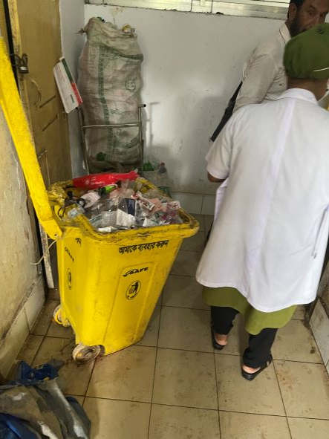
Fig-12: Weak waste management system

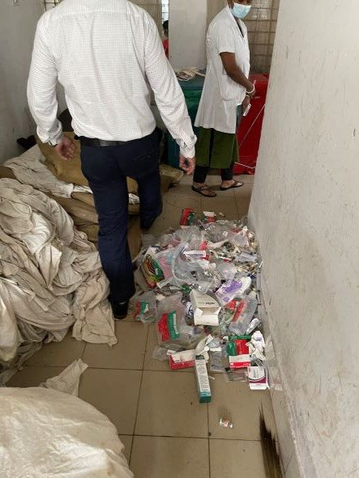
Fig-13: Weak waste management system

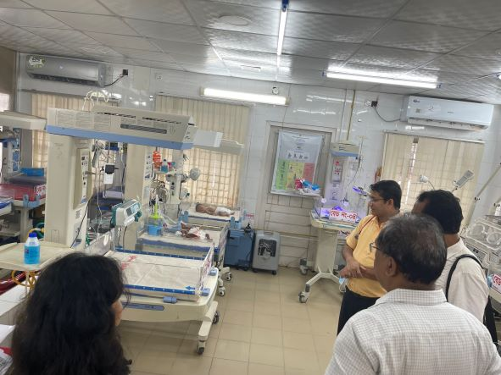

Fig-14: Developed Neonatal Care Unit (Good Practice)

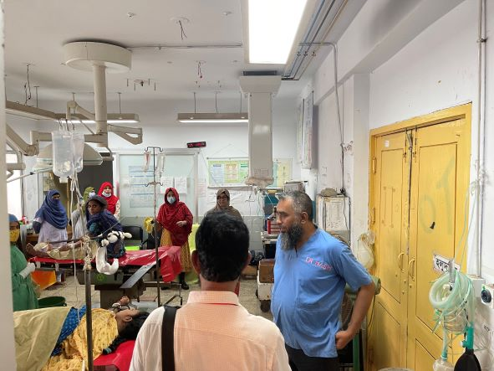

Fig-15: Disorganized OT

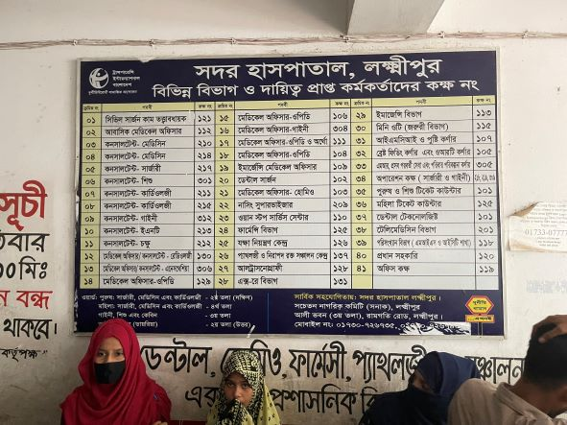
Fig-16: Position Board (Good Practice)

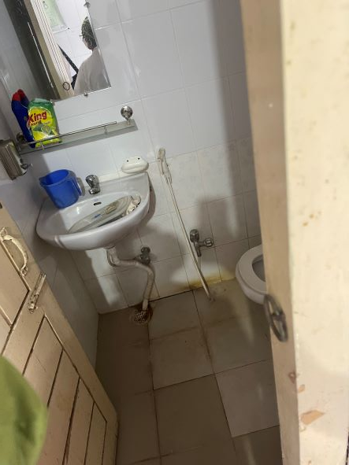

Fig-17: Labor room toilet, but cannot be used by labor patient

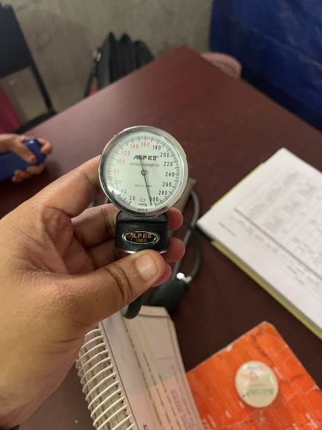

Fig-18: Inaccurate BP machine using in indoor

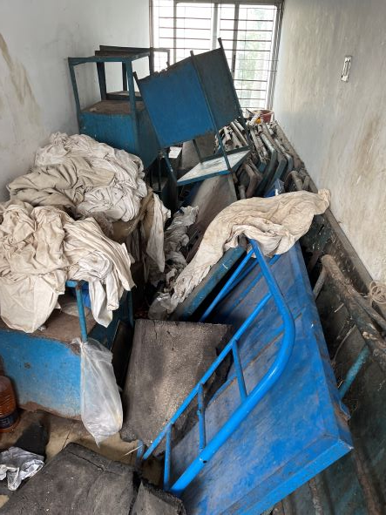

Fig-19: Unwanted items occupied the space of indoor

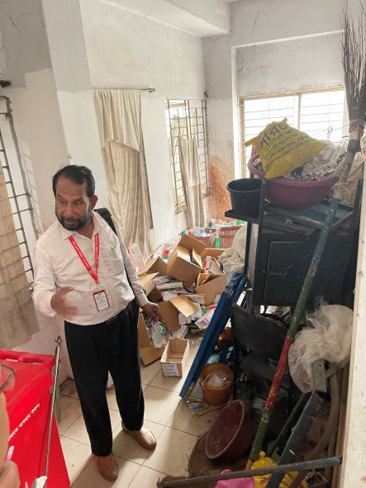

Fig-20: Unwanted items occupied the space of indoor

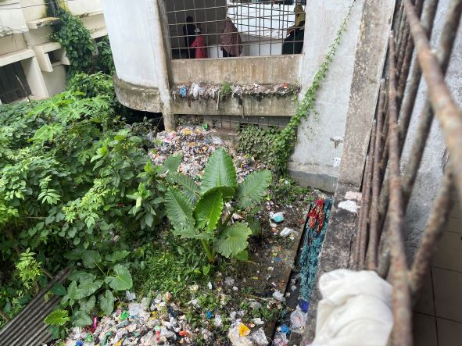

Fig-21: Weak waste management system beside the Hospital building

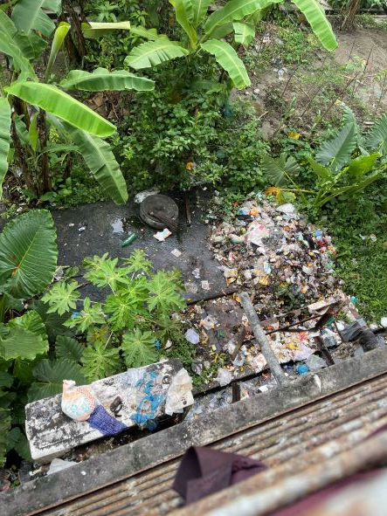
Fig-22: Weak waste management system beside the Hospital building

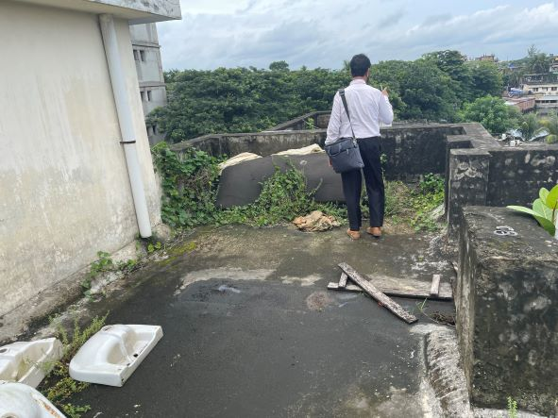

Fig-23: Unclean rooftop of the Hospital building

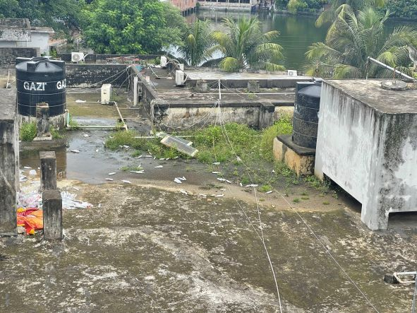

Fig-24: Unclean rooftop of the Hospital building

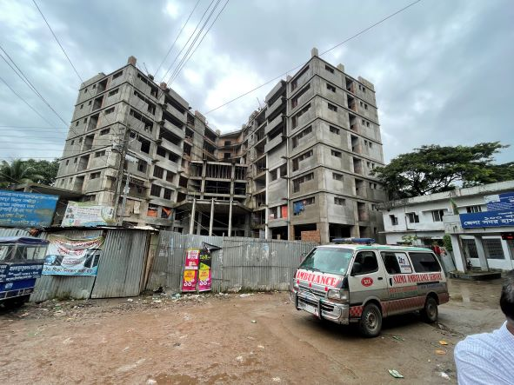

Fig-24: Under construction 150 bedded hospital building
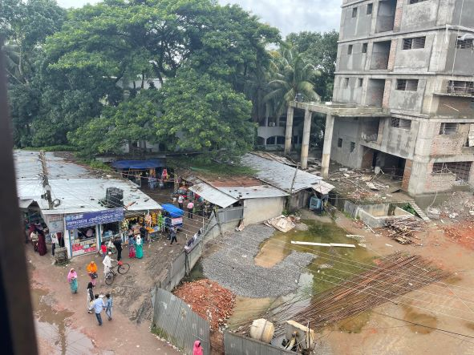
Fig-25: Acquirable important areas inside hospital compound

